# ER Diagram and Scripts:

### Event App:

***Er Diagram:***

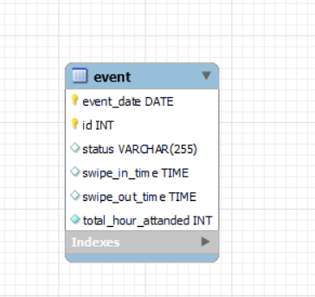

***Script:***

DROP TABLE IF EXISTS `event`;

CREATE TABLE `**event**` (

`event_date` date NOT NULL,

`id` int NOT NULL,

`status` varchar(255) DEFAULT NULL,

`swipe_in_time` time(6) DEFAULT NULL,

`swipe_out_time` time(6) DEFAULT NULL,

`total_hour_attanded` int NOT NULL,

**PRIMARY KEY** (`event_date`,`id`)

) ;

### Attendance App:

***Er Diagram:***

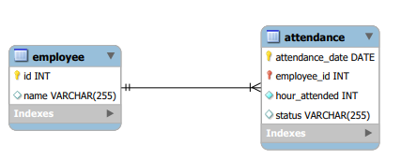

***Script:***

DROP TABLE IF EXISTS `employee`;

CREATE TABLE `**employee**` (

`id` int NOT NULL,

`name` varchar(255) DEFAULT NULL,

**PRIMARY KEY** (`id`)

);

DROP TABLE IF EXISTS `**attendance**`;

CREATE TABLE `attendance` (

`attendance_date` date NOT NULL,

`employee_id` int NOT NULL,

`hour_attended` int NOT NULL,

`status` varchar(255) DEFAULT NULL,

**PRIMARY KEY** (`attendance_date`,`employee_id`),

KEY `event_attandance_idx` (`employee_id`),

CONSTRAINT `event_attandance` **FOREIGN KEY** (`employee_id`) REFERENCES `employee` (`id`)

);